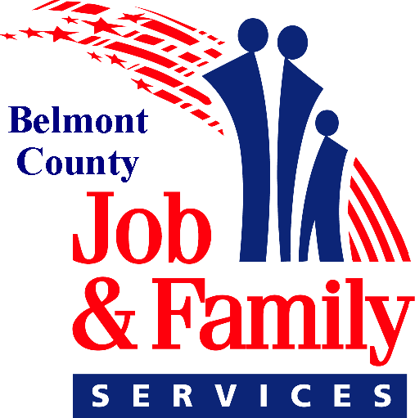
Belmont County Department of Job and Family Services
68145 Hammond Road, St. Clairsville OH 43950
(740) 695-1075

Director County Commissioners
Jeffery Felton Jerry Echemann
Vince Gianangeli
J.P. Dutton

PRESS RELEASE

July 15, 2026

Belmont County Job and Family Services Announces School Clothes for Kids Program Will Not Be Held in 2026

The Belmont County Department of Job and Family Services announces that its annual School Clothes for Kids Program will not be offered this year.

This difficult decision is the result of significant reductions in federal funding and the agency’s need to prioritize the timely and accurate administration of essential public assistance programs, including the Supplemental Nutrition Assistance Program (SNAP).

“While we know this program has benefited many local families over the years, our responsibility is to ensure we continue delivering critical services and meeting federal performance requirements,” said Director Jeff Felton. “We appreciate the community’s understanding as we focus our limited resources on serving Belmont County residents through our core programs.”

The department remains committed to providing essential services to the community and will continue to evaluate opportunities to restore programs like School Clothes for Kids as resources permit.

